Functional Specifications of the "HealthTrace" Software

1. User and Access Management Module
- CU01: MMG and PLS Profile Creation
  - Actor: Administrative staff.
  - Description: The system must allow Administrative Staff to create accounts for General Practitioners (GPs) and Paediatricians of Free Choice (PLS).
  - Requirements:
    - Assign login credentials (username and password).
    - Assign the role and permissions that allow only the activity of reporting infectious diseases.
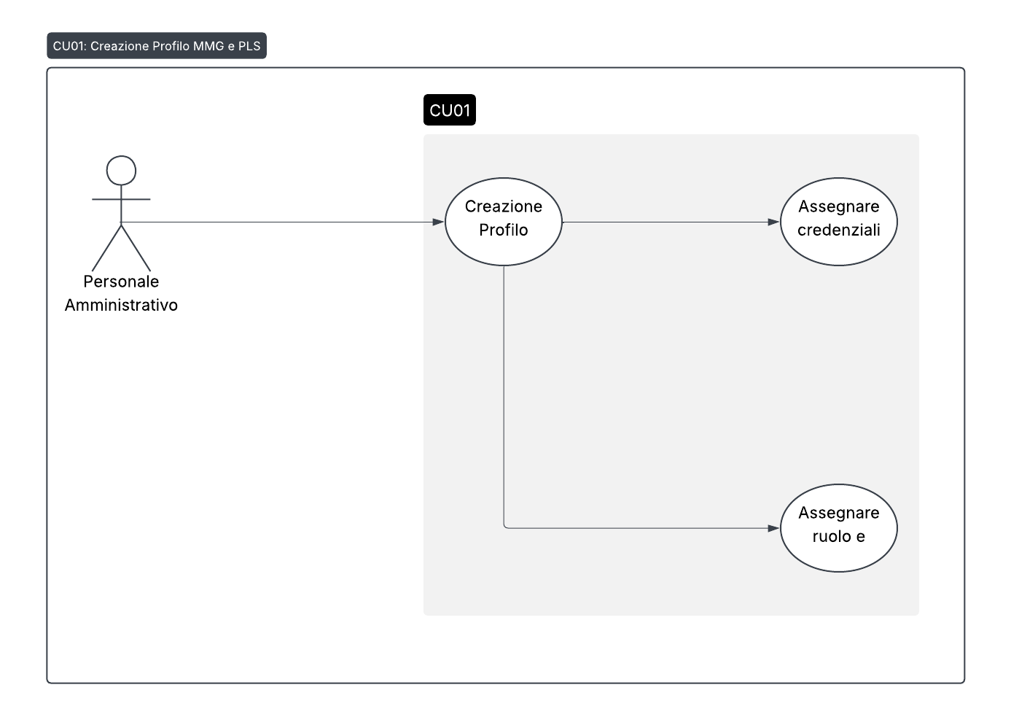
- CU02: U.O.S.D. Medical Profile Creation
  - Actor: Administrative staff.
  - Description: The system must allow the Administrative Staff to create accounts for the Doctors of the U.O.S.D. (Simple Departmental Operating Unit).
  - Requirements:
    - Assign login credentials (username and password).
    - Assign the role and authorizations that allow the epidemiological investigation of infectious diseases to be carried out.
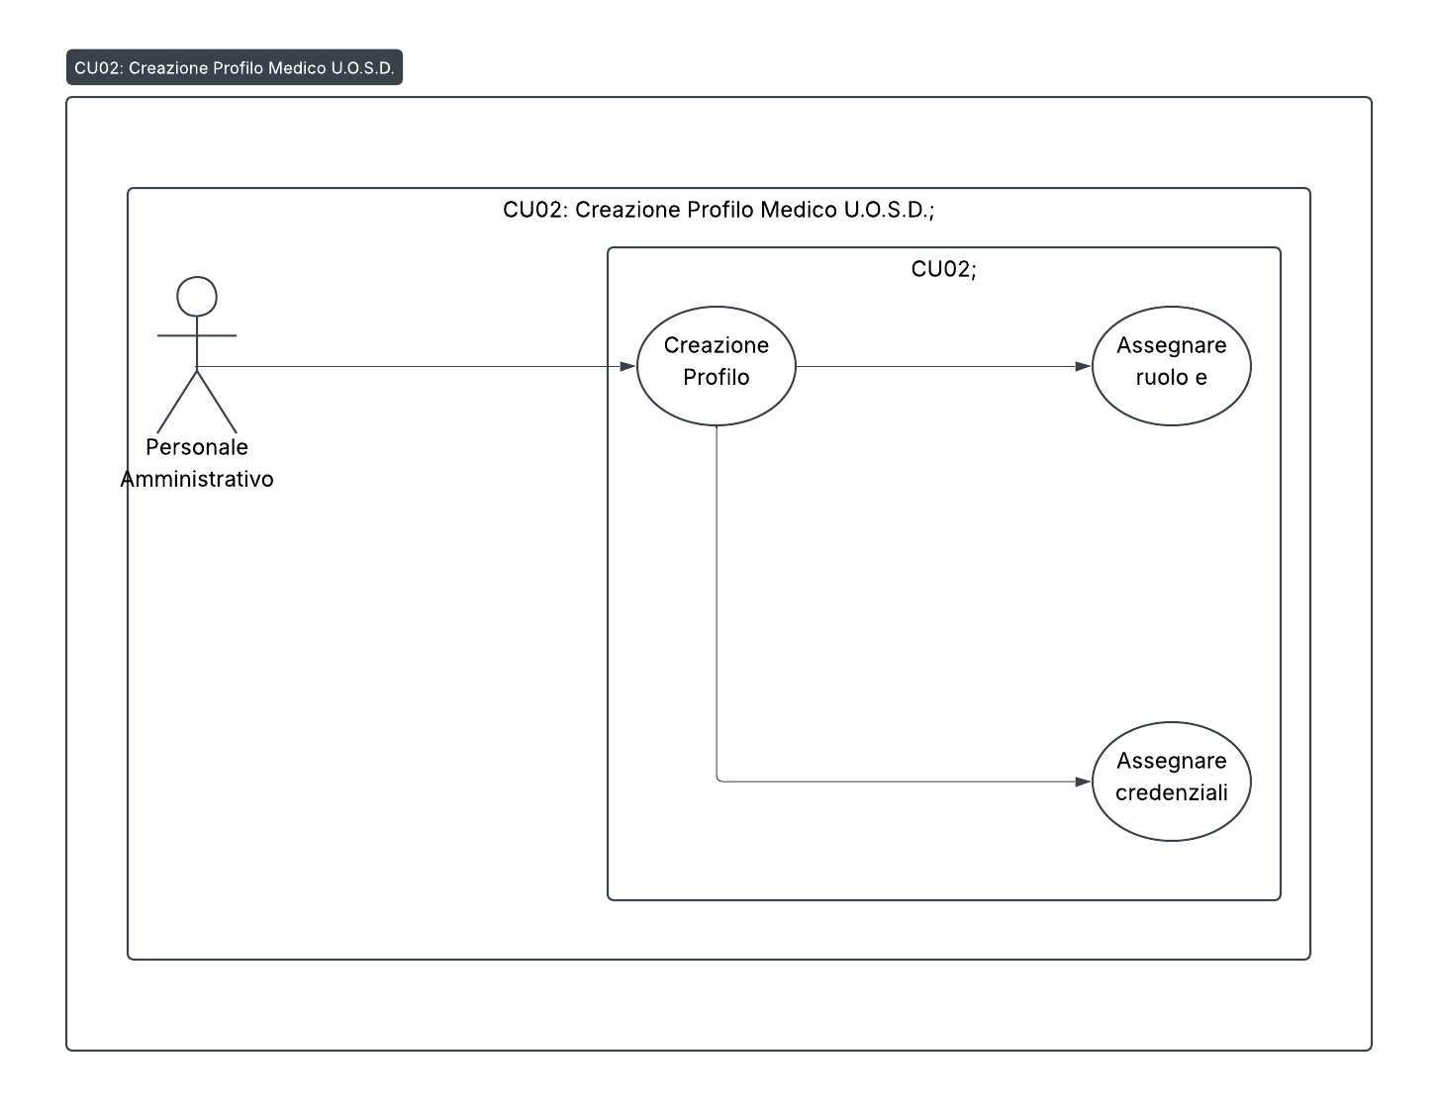
- CU03: Creation of a Medical Profile for the Epidemiology and Prevention Unit
  - Actor: Administrative staff.
  - Description: The system must allow the Administrative Staff to create accounts for the Doctors of the Epidemiology and Prevention Units (Complex Operating Unit).
  - Requirements:
    - Assign login credentials (username and password).
    - Assign the role and authorizations that allow the complete monitoring of both reports and epidemiological investigations.
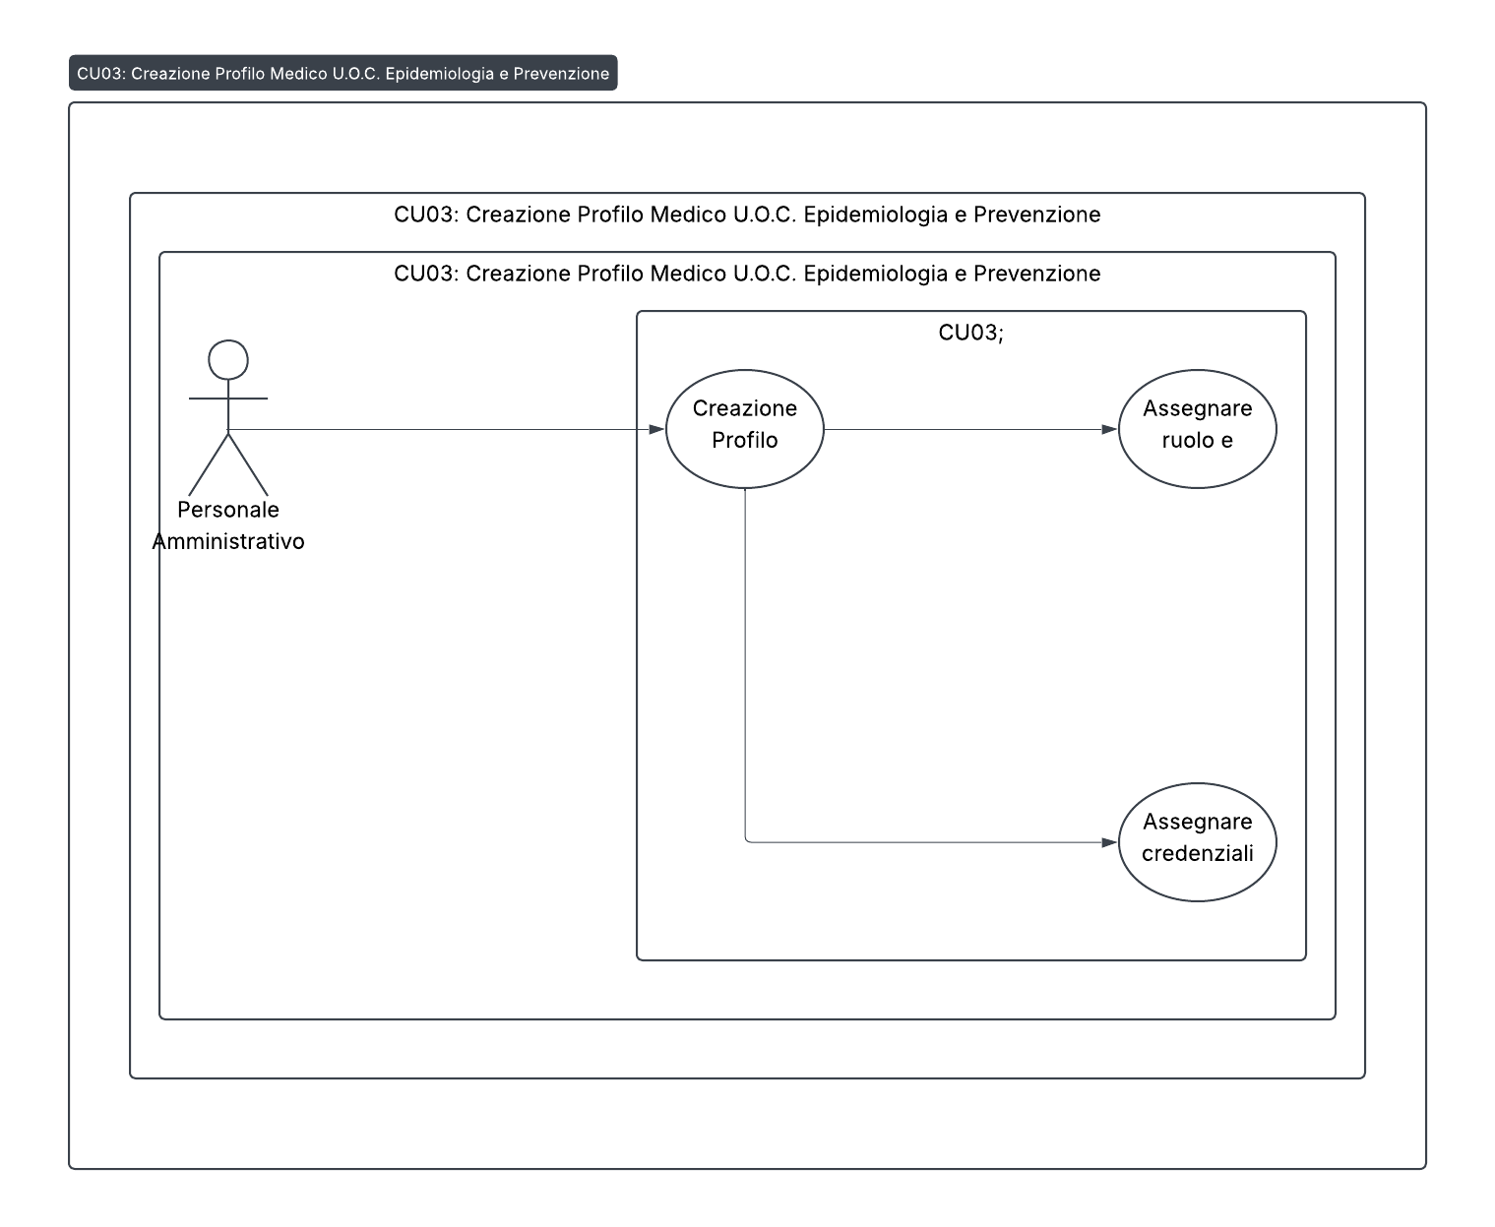
- CU04: System Access
  - Actors: GPs/PLS, U.O.S.D. Doctors, U.O.C. Epidemiology Doctors.
  - Description: The system must allow authorized users to access the platform through a login interface.
  - Requirements:
    - The user must enter their username and password for authentication.
    - Once authenticated, the user is redirected to the home page.
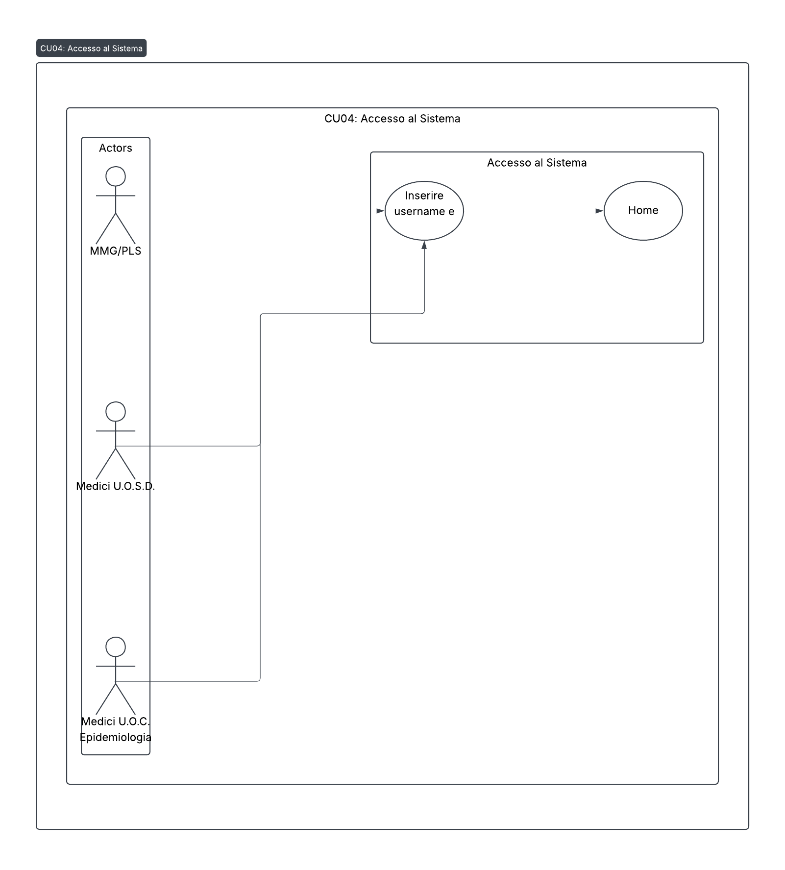
2. Reports Form
- CU05: Infectious Disease Reporting
  - Actors: GPs, PLS, Doctors U.O.C. Epidemiology.
  - Description: The system must provide an interface for entering a new infectious disease report.
  - Flow:
    - The user navigates to the "Reports" section.
    - The user selects "New Report" to open the form.
    - The user fills in the fields of the form.
    - The user saves the report.
  - Required data:
    - Disease Information: Infectious Disease, Diagnosis UOSD.
    - Patient Personal Data: Tax Code/STP/ENI, Surname, Name, Sex, Date of Birth, Place of Birth (Country, Province, Municipality).
    - Other Data: Profession, Residence/domicile information (address and municipality), Telephone contact.
    - Initial Clinical Data: Date and Municipality of onset of symptoms, Hospitalization (Yes/No), Vaccination status (Vaccinated/Unvaccinated/Unknown), Number of doses, Date of last dose, Type of vaccine.
    - Reporting Data: Name and Surname of the Reporting Doctor, Telephone Contact, Date of Reporting.
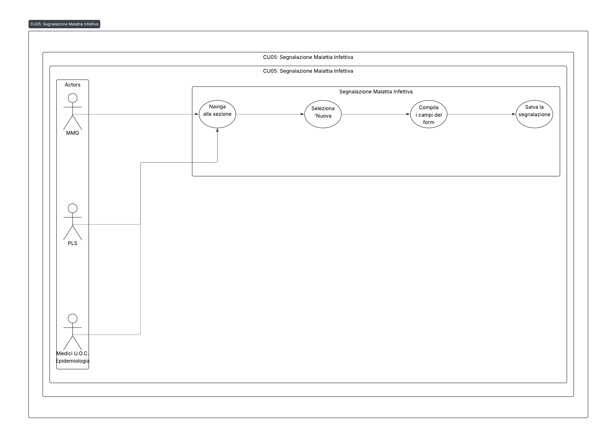
- CU06: Patient Research
  - Actors: GPs, PLS, Doctors U.O.C. Epidemiology.
  - Description: The system must allow the search for a patient already present in the platform.
  - Requirements:
    - The user must be able to search by Name, Surname and Tax Code.
    - The system should display search results (if any) or a "no results" message.
    - By clicking on the patient, the personal data and clinic card must be opened.
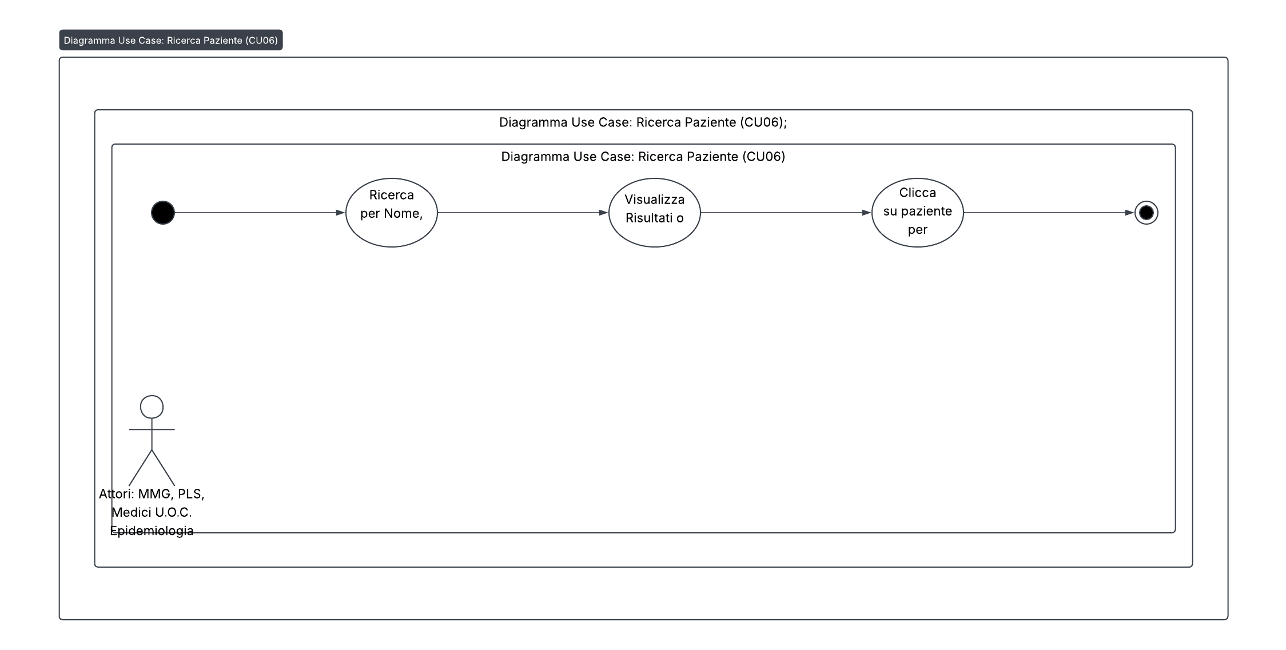
- CU07: View Patient
  - Actors: GPs, PLS, Doctors U.O.C. Epidemiology.
  - Description: The system must allow the display of a complete patient record.
  - Requirements: The card must show all the personal and clinical data associated with the patient.
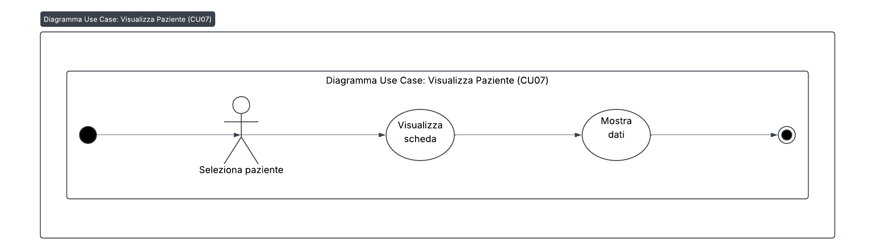
- CU08: Patient Change
  - Actors: GPs, PLS, Doctors U.O.C. Epidemiology.
  - Description: The system must allow editing of an existing patient's reporting data.
  - Requirements:
    - The user can change the data entered in the report form.
    - The system must record and save the changes.
    - The user must be able to change the status of the disease:
      - On (red light).
      - Recovered (green light).
      - Death (black light).
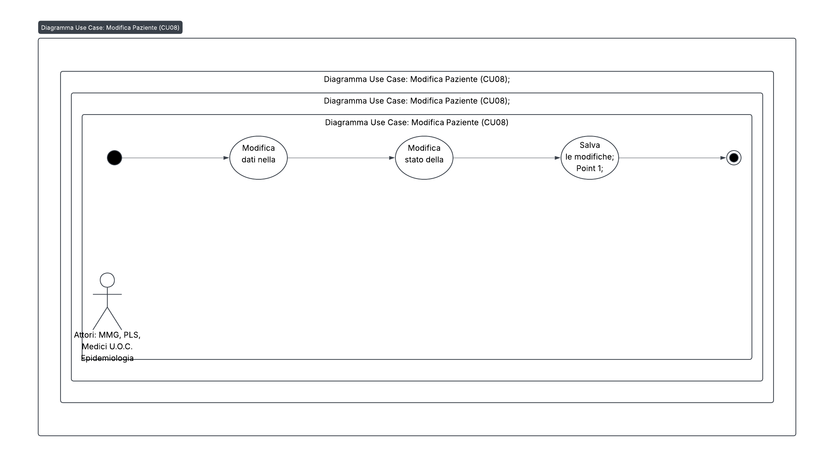
- CU09: Research by Infectious Disease
  - Actors: GPs, PLS, Doctors U.O.C. Epidemiology.
  - Description: The system must allow the search for patients by specific infectious disease.
  - Requirements:
    - The user must be able to search by disease name.
    - The system must show the list of patients associated with that disease or a "no result" message.
    - Clicking on a patient from the list opens their card.
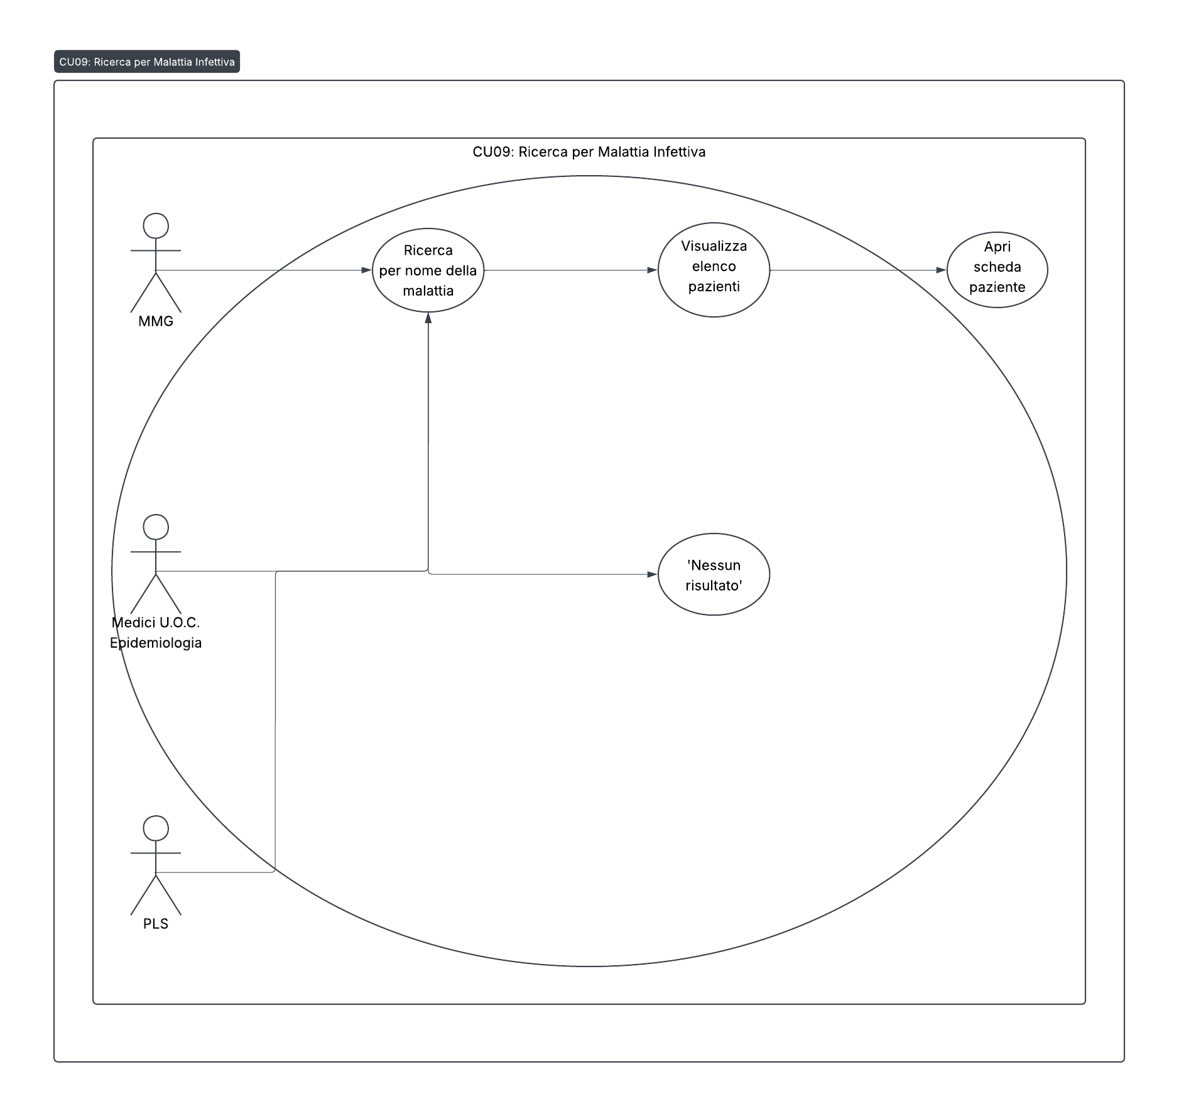

3. Epidemiological Investigations and Special Cases Module
- CU10: Epidemiological investigation
  - Actors: U.O.S.D. Doctors, U.O.C. Epidemiology Doctors.
  - Description: The system must allow the recording of an epidemiological investigation for a patient.
  - Requirements:
    - Once the patient has been identified, the user can fill in additional clinical data, including:
      - Case type (Probable/Established).
      - Symptomatology.
      - Possible source of contagion.
      - Staying in foreign countries.
      - Diagnostic searches performed (with type, date, place and result).
      - Information on the patient's contacts (kinship, personal data, profession).
      - Information about data collection (Health care provider who filled in, contact, date).
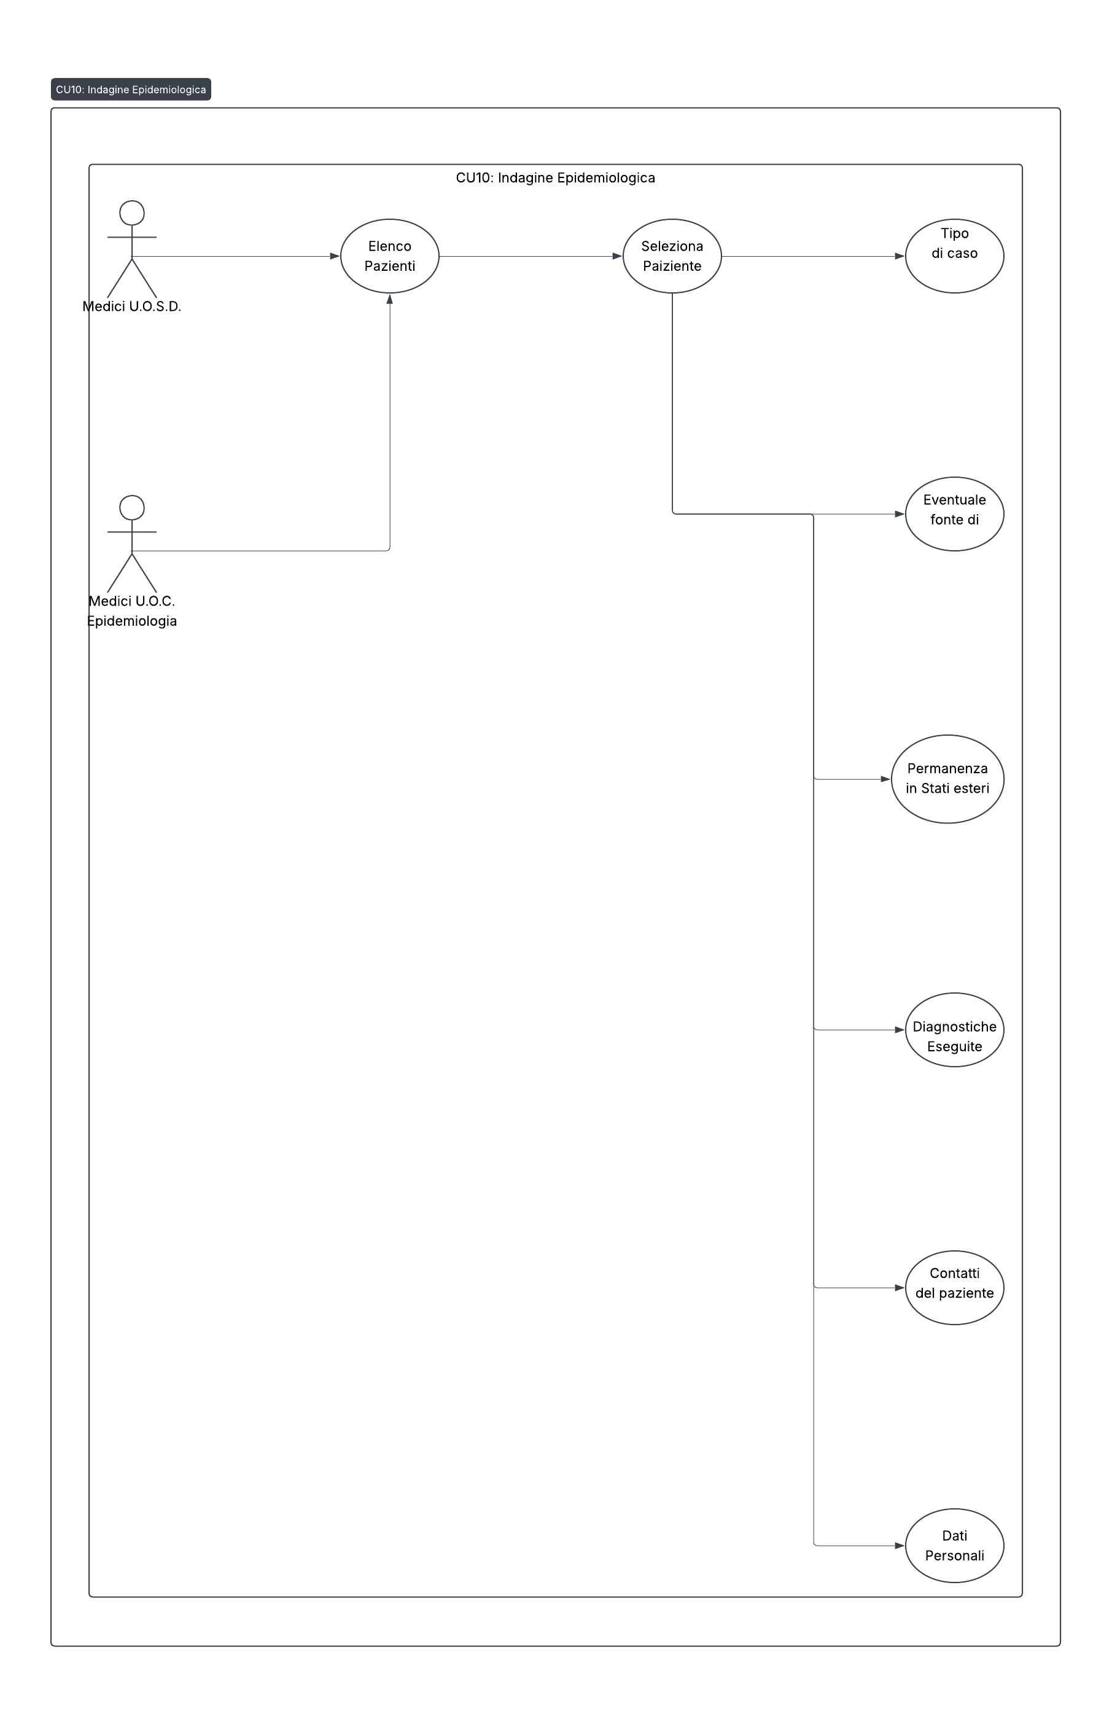
- CU11 - CU17: Disease-Specific Modules
  - Actors: U.O.S.D. Doctors, U.O.C. Epidemiology Doctors.
  - Description: The system must provide specific survey forms, with detailed and predefined fields, for the following pathologies. Each form must be accessible from the patient's file and allow the compilation and saving of data.
  - Pathologies with specific forms:
    - CU11 - Influenza: Data on hospitalization, antiviral therapy, presence of chronic diseases, laboratory data (A(H1N1)v, A(H1N1), A(H3N2), B), complications and follow-up (recovery/death).
    - CU12 - Botulism: Data on the source of contagion (suspected food), specific clinical symptoms (e.g. diplopia, dysphagia), instrumental diagnosis, course (hospitalization, anti-botulinum serum) and laboratory investigations (search for toxins on serum, feces, food, etc.).
    - CU13 - Tetanus: Data on injuries/wounds, drug use, recent surgeries, and other risk factors.
    - CU14 - Encephalitis, Meningitis, Meningococcal Syndrome: Data on the type of disease, symptoms, medical history, test results (Spinal Tap, PCR, Now Test), causative agent and contact information.
    - CU15 - Legionnaires' disease: Clinical data (hospitalization, specific symptoms, concomitant diseases), anamnestic investigations (therapies, stays in different places, smoking, alcohol) and laboratory diagnosis (germ isolation, serology, urinary antigen).
    - CU16 - Listeriosis: Data on hospitalization, diagnostic protocol, presence of cases in the family and eating habits.
    - CU17 - Measles and rubella: Data on vaccination status, belonging to specific categories (health, school), clinical symptoms and laboratory confirmation (IgM, IgG research).
4. Dashboard and Data Visualization Module
- CU18: Summary and Monitoring Dashboard
  - Actors: Doctors U.O.C. Epidemiology.
  - Description: The system shall provide a summary dashboard to view the volume and progress of reports and investigations at the aggregate level.
  - Requirements:
    - Quantitative Graphs: Display the total number of reports and epidemiological investigations on a temporal basis (daily, weekly, monthly).
    - Pie Charts/Bars: Show the distribution of reports by pathology and by U.O.S.D. of diagnosis.
    - Interactive Filters: Allow the user to filter data by a specific time period or by pathology.
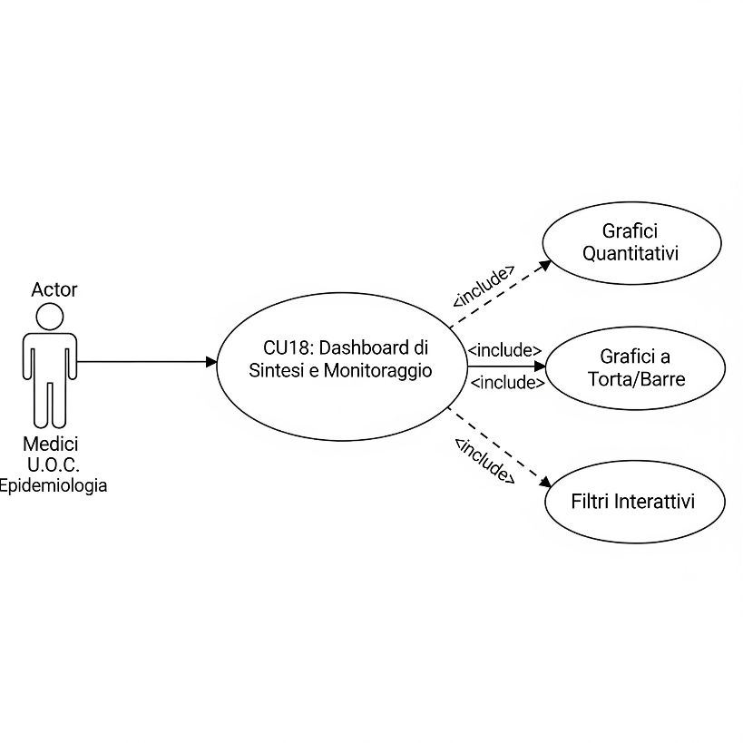

- CU19: Geo-View Dashboard
  - Actors: Doctors U.O.C. Epidemiology.
  - Description: The system must represent georeferenced data on an interactive map.
  - Requirements:
    - Interactive map: Visualize the distribution of cases and investigations on a geographical map (e.g. map of Italy with subdivision by region, province, municipality).
    - Heatmap: Represent the density of cases in a given area to identify "clusters" of infection.
    - Geographic Filters: The user must be able to zoom in on a specific geographic area and view data relevant to that territory.
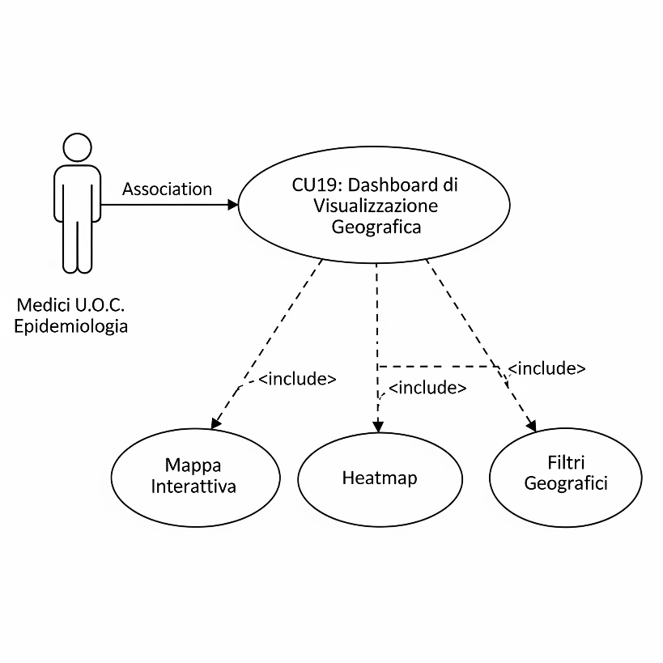

- CU20: Environmental Data Correlation Dashboard
  - Actors: Doctors U.O.C. Epidemiology, Researchers.
  - Description: The platform must offer a dedicated dashboard that correlates the incidence of infectious diseases with environmental data.
  - Requirements:
    - Data Integration: The system must be able to import and display weather-related data such as PM2.5, PM10, Ozone, Humidity and Temperature.
    - Correlation graphs: Present time-series graphs that superimpose the trend of reported cases of a specific pathology (e.g. respiratory diseases) with the trend in air pollutant levels for the same geographical area and period.
    - Data Analysis: This feature is used to explore epidemiological hypotheses, such as the possible correlation between PM2.5 exposure and increased respiratory infections. Air pollution can in fact compromise the immune system and act as a vector for pathogens, making the body more vulnerable. The dashboard should help highlight these complex interactions.





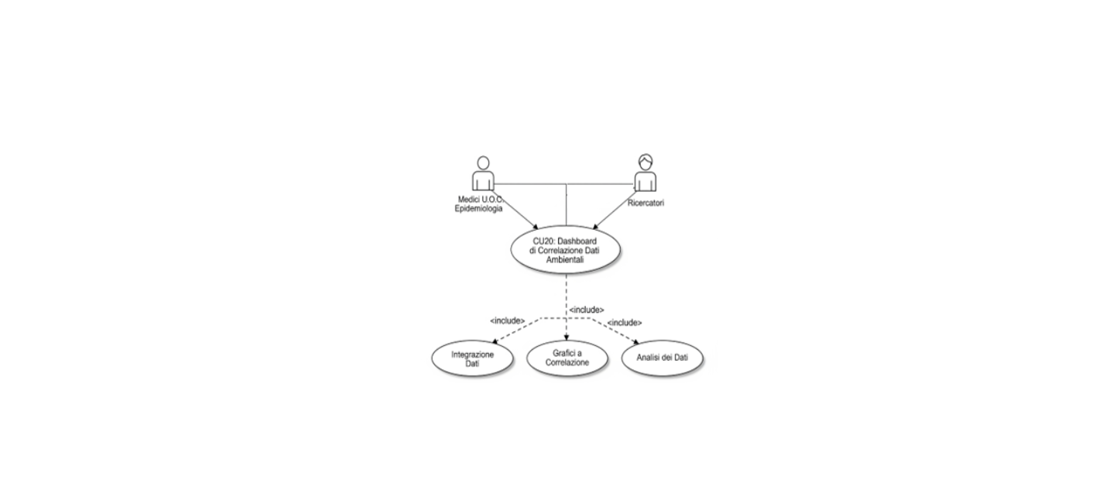

Correlation Atmospheric agents
Some environmental data are reported below:
- Temperature
- PM10,
- PM2.5,
- Inland waters
- Solar radiation (UV)
- Ozone
- Nitrogen Dioxide (NO₂)
- Humidity
- Rainfall
- Atmospheric pressure
- Wind speed.
API
- istat/year/interval/function/pollutant/
  - Interval:
    - 1 to 12, reference month
    - 0, full year
  - Function:
    - Average Range
    - Maximum Range Value
  - Istat:
    - Municipality Code
    - Province code
    - Region code
- /climate/istat/year/interval/measurement/function/
  - Function
    - Precipitation sum
    - Number of days with precipitation
Several databases for environmental data are reported:
- https://indicatoriambientali.isprambiente.it/it/temi
- https://www.isprambiente.gov.it/it/banche-dati
- https://www.snpambiente.it/dati/
- https://dati.arpacampania.it/
- https://dati.arpacampania.it/dataset/monitoraggio-acque-superficiali-s07

NB: The system must have a function to load data in real time or massively through an excel file import system.

Block diagram
Here are some solutions
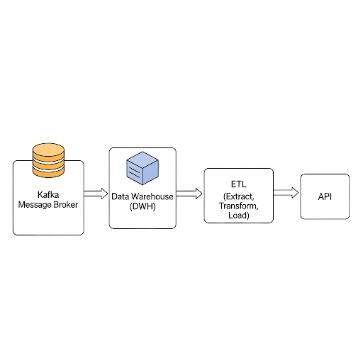
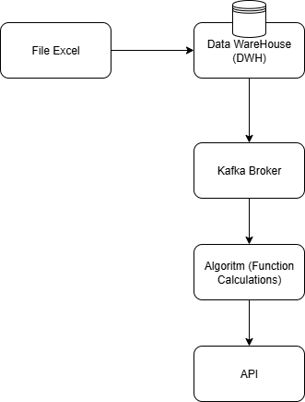

Infectious diseases
The most typical correlations are:
- Respiratory Diseases (Influenza, Legionellosis): Fine particulate matter (PM10, PM2.5), nitrogen dioxide (NO2) and sulfur dioxide (SO2) have a strong link with infectious diseases of the respiratory system. These particles and gases not only damage the airways, compromising local immune defenses, but can also act as vectors for viruses and bacteria, facilitating their penetration and spread in the body. Legionnaires' disease, although caused by a bacterium that develops in water, can be transmitted through the inhalation of contaminated aerosols, a process influenced by atmospheric conditions.
- Airborne Infections (Measles, Rubella, Encephalitis, Meningitis): These viral and bacterial diseases are spread mainly through the air. Fine particulate matter (PM10, PM2.5) can promote their transmission by acting as a "means of transport" for pathogens, contributing to greater dispersion in the environment.
- Other Pathologies (Botulism, Tetanus, Listeriosis): For pathologies such as Botulism and Listeriosis (typically food) and Tetanus (linked to wounds), the correlation with atmospheric agents is less direct and more indirect. Exposure to pollutants such as benzene and carbon monoxide (CO) can weaken the immune system as a whole, making an individual more susceptible to infections of various kinds. However, there is no direct causal link between the presence of these pollutants in the air and the transmission mechanism of these specific diseases.
- Vector-Borne Diseases (Malaria, Dengue, Chikungunya, Zika): These diseases are closely linked to vectors, mainly mosquitoes. Environmental correlations include:
- Temperature and Humidity: Factors that affect the reproduction and survival of mosquitoes. Rising global temperatures are expanding mosquito habitat to new geographic areas.
- Rainfall and Floods: They create the ideal conditions (stagnant water) for mosquito eggs to be laid, causing an increase in vector populations.
- Land Use Changes: Deforestation or unplanned urbanization can alter natural habitats, bringing insect vectors into closer contact with human communities.
- Waterborne diseases (cholera, typhoid, hepatitis A): The spread of these pathogens is linked to water quality. Environmental correlations include:
- Water Pollution: Contamination of groundwater or water sources with human or animal feces is the main route of transmission. Data such as water pH, the presence of indicator bacteria (E. coli) and residual chlorine levels are critical.
- Extreme Weather Events: Floods, hurricanes or torrential rains can damage water and sewage infrastructure, mixing drinking water with contaminated wastewater.
- Zoonotic Diseases (Plague, Lyme Disease): These infections pass from animals to humans. Environmental correlations include:
- Vector Density and Distribution: The tick population (for Lyme disease) or rodent population (for plague) is the main risk factor. Climatic conditions, vegetation and soil moisture directly influence their proliferation.
- Habitat Destruction: Fragmentation of ecosystems forces wild animals and their pathogens to live in close proximity to inhabited areas, increasing the risk of spillover.

